K226007

DBMS LAB 9

BCS-5L

DML TRIGGERS:

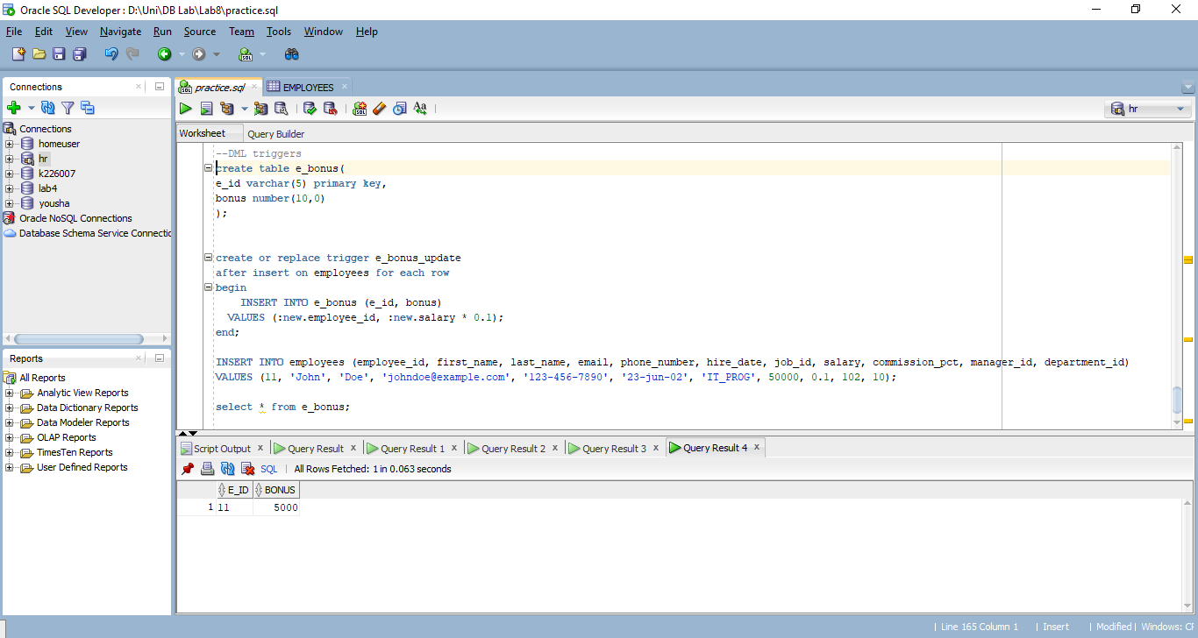

create table e_bonus(

e_id varchar(5) primary key,

bonus number(10,0)

);

create or replace trigger e_bonus_update

after insert on employees for each row

begin

INSERT INTO e_bonus (e_id, bonus)

VALUES (:new.employee_id, :new.salary * 0.1);

end;

INSERT INTO employees (employee_id, first_name, last_name, email, phone_number, hire_date, job_id, salary, commission_pct, manager_id, department_id)

VALUES (11, 'John', 'Doe', 'johndoe@example.com', '123-456-7890', '23-jun-02', 'IT_PROG', 50000, 0.1, 102, 10);

select * from e_bonus;

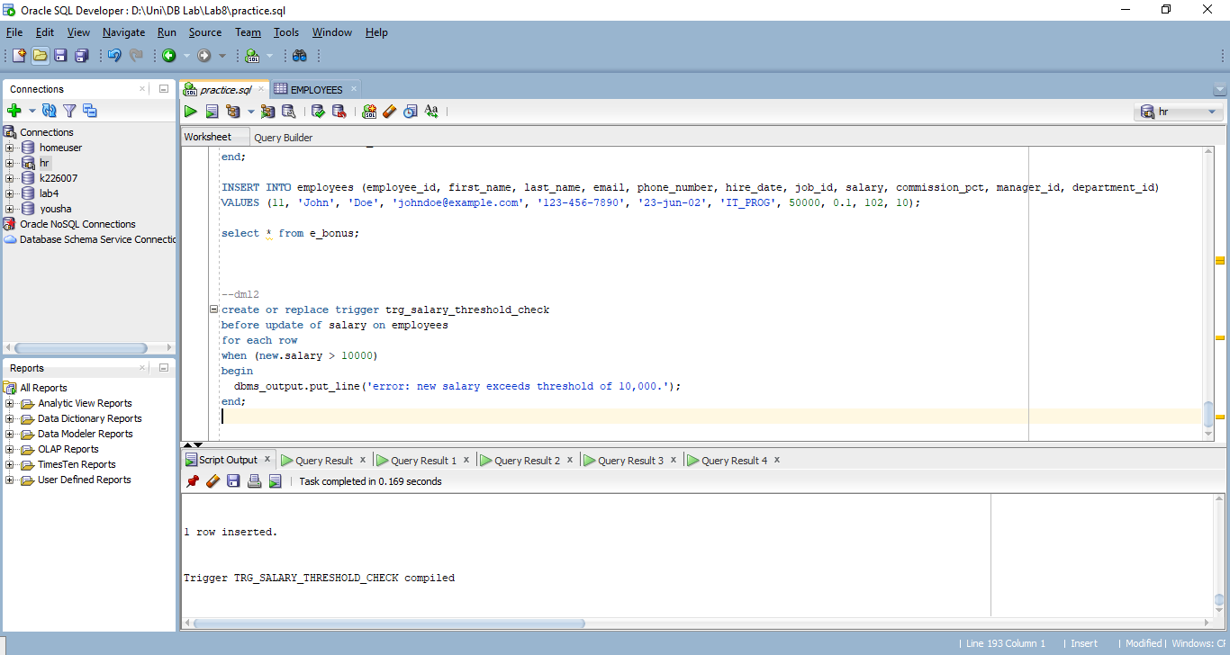

create or replace trigger trg_salary_threshold_check

before update of salary on employees

for each row

when (new.salary > 10000)

begin

dbms_output.put_line('error: new salary exceeds threshold of 10,000.');

end;

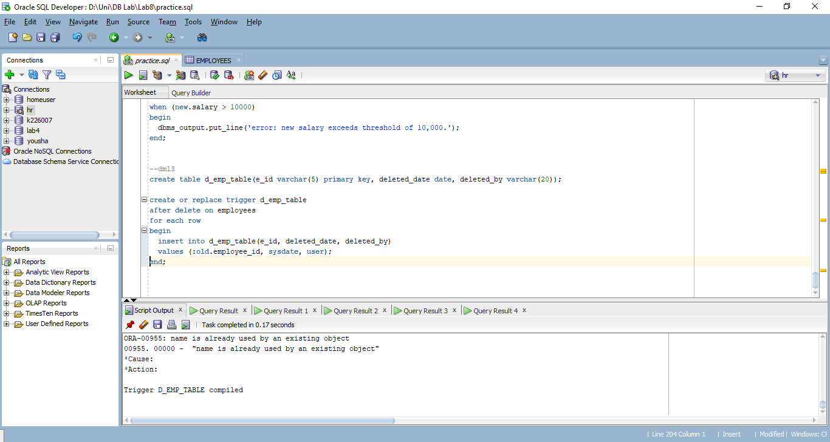

create table d_emp_table(e_id varchar(5) primary key, deleted_date date, deleted_by varchar(20));

create or replace trigger d_emp_table

after delete on employees

for each row

begin

insert into d_emp_table(e_id, deleted_date, deleted_by)

values (:old.employee_id, sysdate, user);

end;

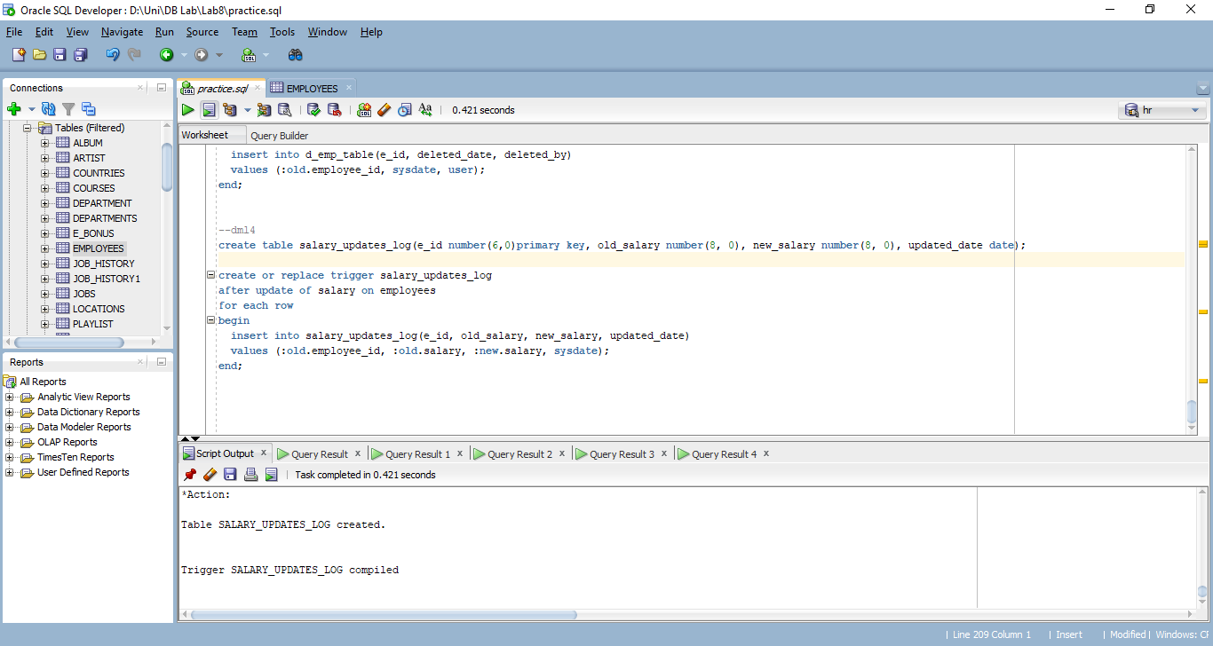  
  
create table salary_updates_log(e_id number(6,0)primary key, old_salary number(8, 0), new_salary number(8, 0), updated_date date);

create or replace trigger salary_updates_log

after update of salary on employees

for each row

begin

insert into salary_updates_log(e_id, old_salary, new_salary, updated_date)

values (:old.employee_id, :old.salary, :new.salary, sysdate);

end;

DDL Commands:

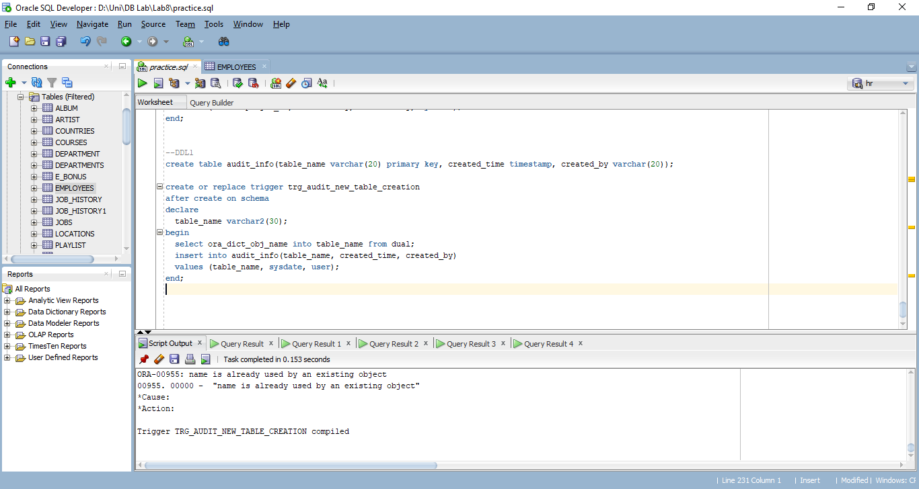

create table audit_info(table_name varchar(20) primary key, created_time timestamp, created_by varchar(20));

create or replace trigger trg_audit_new_table_creation

after create on schema

declare

table_name varchar2(30);

begin

select ora_dict_obj_name into table_name from dual;

insert into audit_info(table_name, created_time, created_by)

values (table_name, sysdate, user);

end;

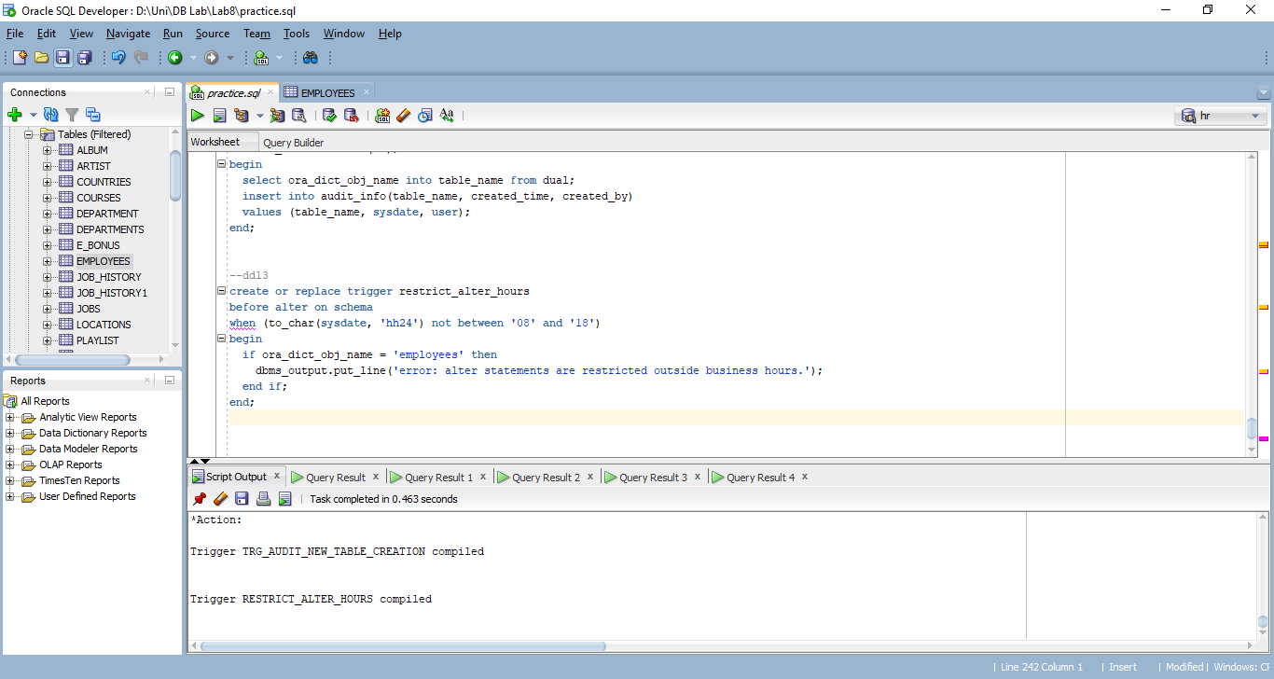

create or replace trigger restrict_alter_hours

before alter on schema

when (to_char(sysdate, 'hh24') not between '08' and '18')

begin

if ora_dict_obj_name = 'employees' then

dbms_output.put_line('error: alter statements are restricted outside business hours.');

end if;

end;

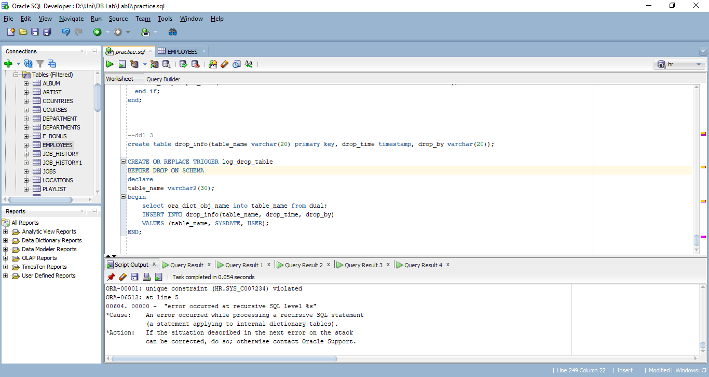

create table drop_info(table_name varchar(20) primary key, drop_time timestamp, drop_by varchar(20));

CREATE OR REPLACE TRIGGER log_drop_table

BEFORE DROP ON SCHEMA

declare

table_name varchar2(30);

begin

select ora_dict_obj_name into table_name from dual;

INSERT INTO drop_info(table_name, drop_time, drop_by)

VALUES (table_name, SYSDATE, USER);

END;

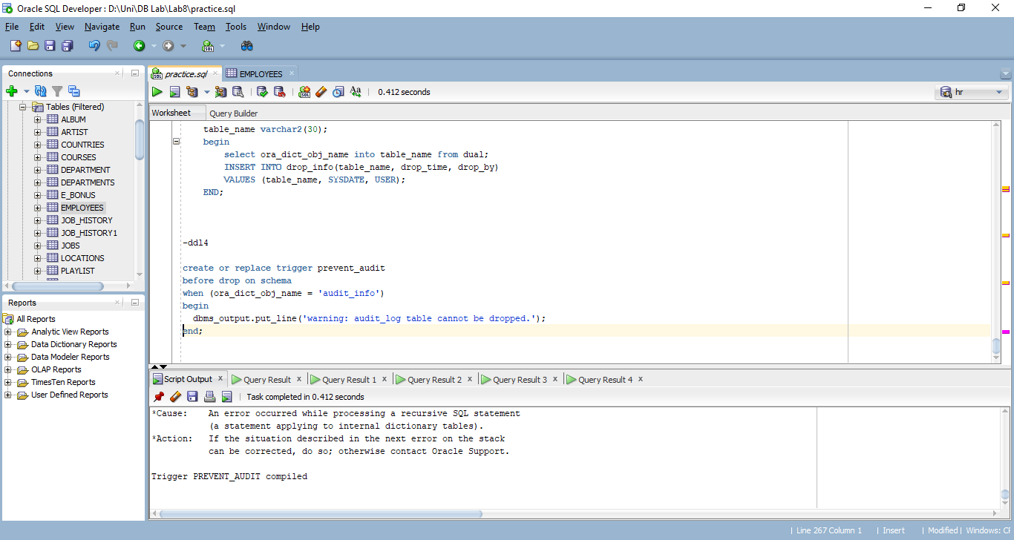

create or replace trigger prevent_audit

before drop on schema

when (ora_dict_obj_name = 'audit_info')

begin

dbms_output.put_line('warning: audit_log table cannot be dropped.');

end;

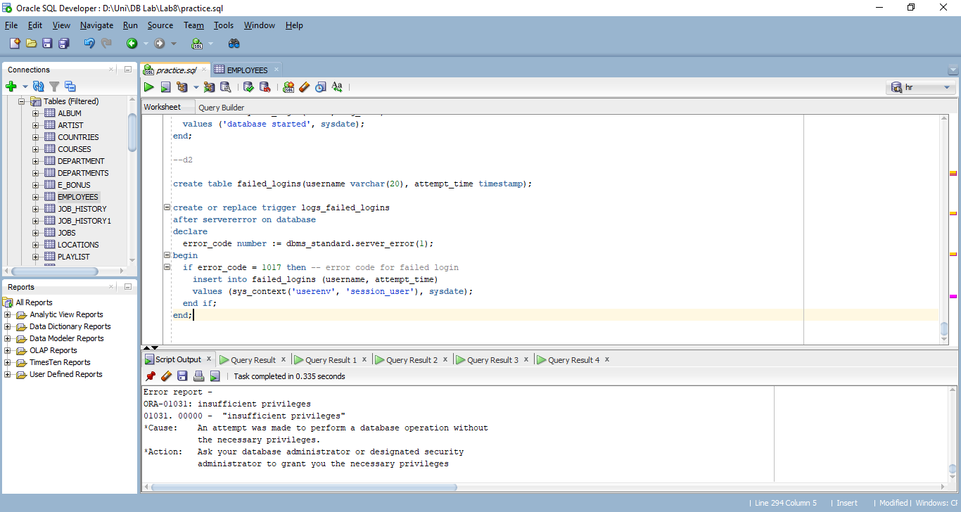

create table failed_logins(username varchar(20), attempt_time timestamp);

create or replace trigger logs_failed_logins

after servererror on database

declare

error_code number := dbms_standard.server_error(1);

begin

if error_code = 1017 then -- error code for failed login

insert into failed_logins (username, attempt_time)

values (sys_context('userenv', 'session_user'), sysdate);

end if;

end;

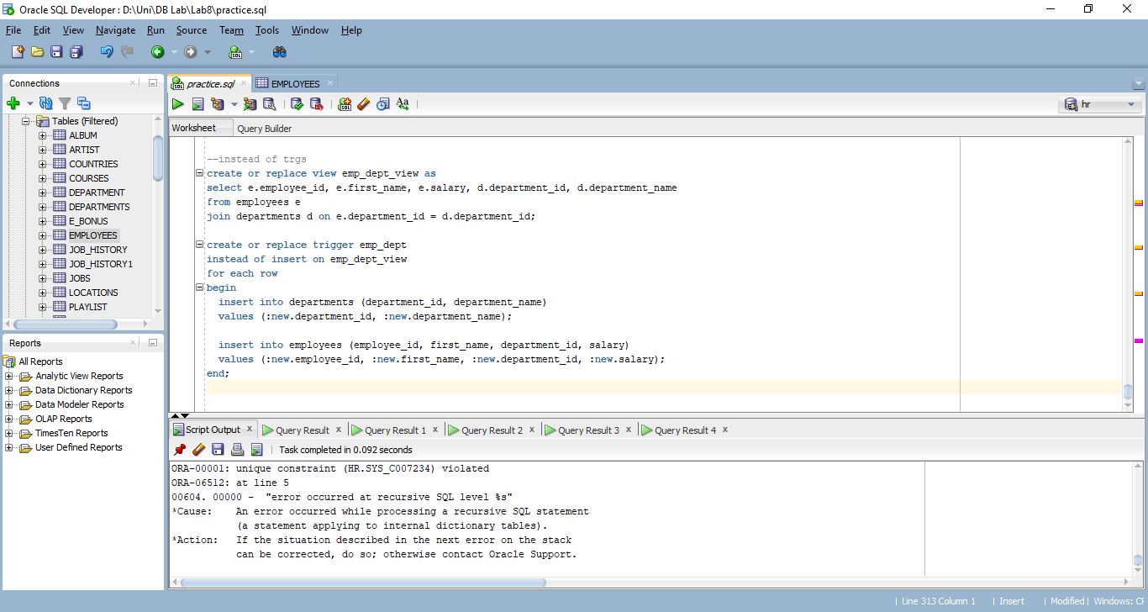

create or replace view emp_dept_view as

select e.employee_id, e.first_name, e.salary, d.department_id, d.department_name

from employees e

join departments d on e.department_id = d.department_id;

create or replace trigger emp_dept

instead of insert on emp_dept_view

for each row

begin

insert into departments (department_id, department_name)

values (:new.department_id, :new.department_name);

insert into employees (employee_id, first_name, department_id, salary)

values (:new.employee_id, :new.first_name, :new.department_id, :new.salary);

end;

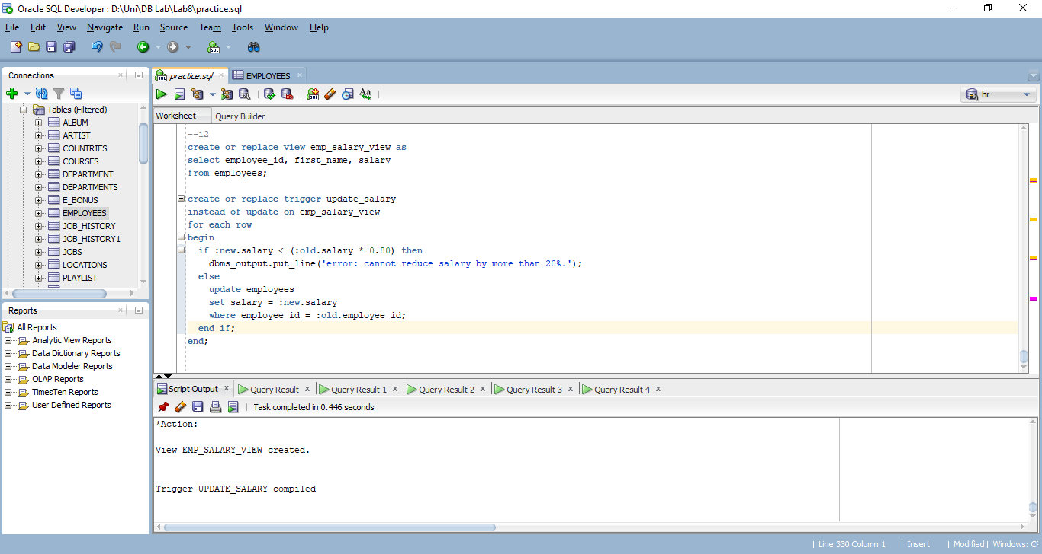

create or replace view emp_salary_view as

select employee_id, first_name, salary

from employees;

create or replace trigger update_salary

instead of update on emp_salary_view

for each row

begin

if :new.salary < (:old.salary * 0.80) then

dbms_output.put_line('error: cannot reduce salary by more than 20%.');

else

update employees

set salary = :new.salary

where employee_id = :old.employee_id;

end if;

end;